Master/Hons/Research assistant project
Fate of erionite in New Zealand soil

Interested in studying the environmental fate of erionite, the new asbestos? This project involving laboratory work at the University of Auckland may be for you!
Background: Erionite is a naturally occurring mineral fiber with a needle-like morphology that is linked with malignant mesothelioma: a disease typically associated with exposure to asbestos. Erionite was recently found at different locations on the North and South Island of New Zealand. There is thus an urgent need to look at the occurrence and fate of erionite in soil, with the aim of assessing and managing the risk to human health.
Master/Hons/Research assistant project opportunity: you will conduct tests that will help understand what happens to erionite once it is in soil and how weathering processes may affect its chemistry and, thus, toxicity. You will get trained in several analytical techniques, including scanning electron microscope, ICP-MS, and XRD.
You: our ideal candidate has a strong interest in soil chemistry and/or geochemistry and/or environmental chemistry. You are keen to integrate a multidisciplinary team of researchers and students. Depending on the duration of the project, there are opportunities to collaborate with researchers in Europe. Scholarship/remuneration is available for the right candidate(s).
The research team and supervisors: This is part of a large multidisciplinary project on the occurrence, fate and risk associated with erionite. https://www.auckland.ac.nz/en/news/2020/09/24/what-lies-beneath-the-new-asbestos.html
Melanie Kah: https://profiles.auckland.ac.nz/melanie-kah
Martin Brook: https://profiles.auckland.ac.nz/m-brook

The project could start immediately (April 2024) or later in the year. If you are qualified and interested, please send your CV and motivations to melanie.kah@auckland.ac.nz

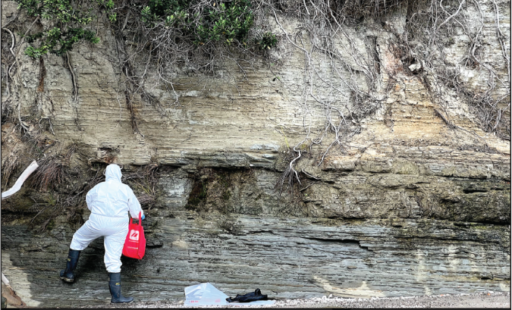 | 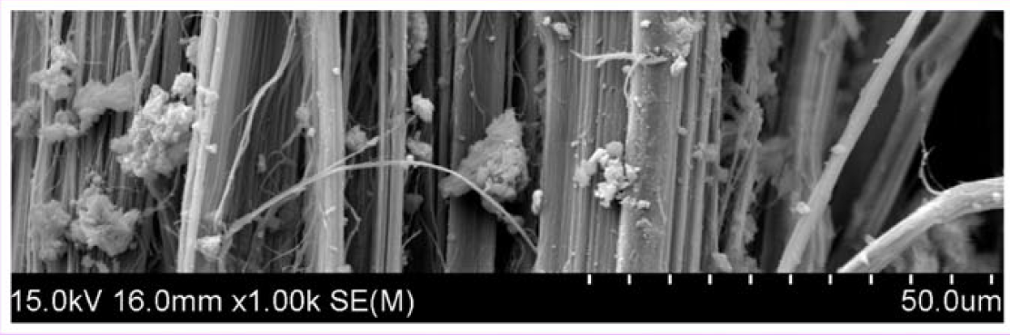
Student sampling to find erionite | Scanning Electron micrograph of woolly erionite recently found in New Zealand

